Github URL : https://github.com/Siva2984/MobileHandset

Clone the project from the above URL.This is public repository.

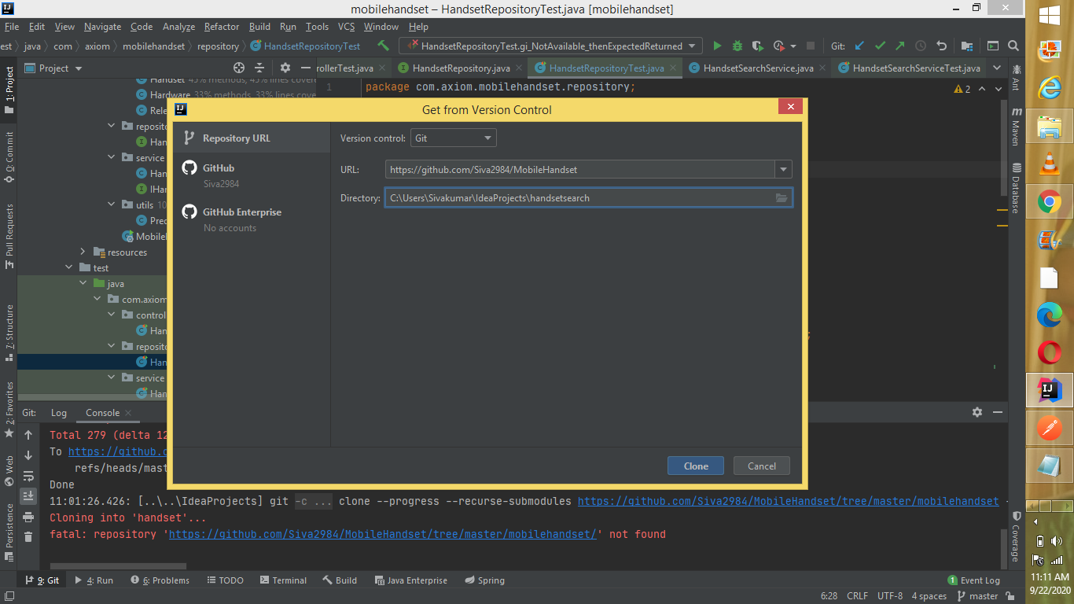

Verify lombok plugin is installed in Intellij:

If not, Kindly install the plugin.

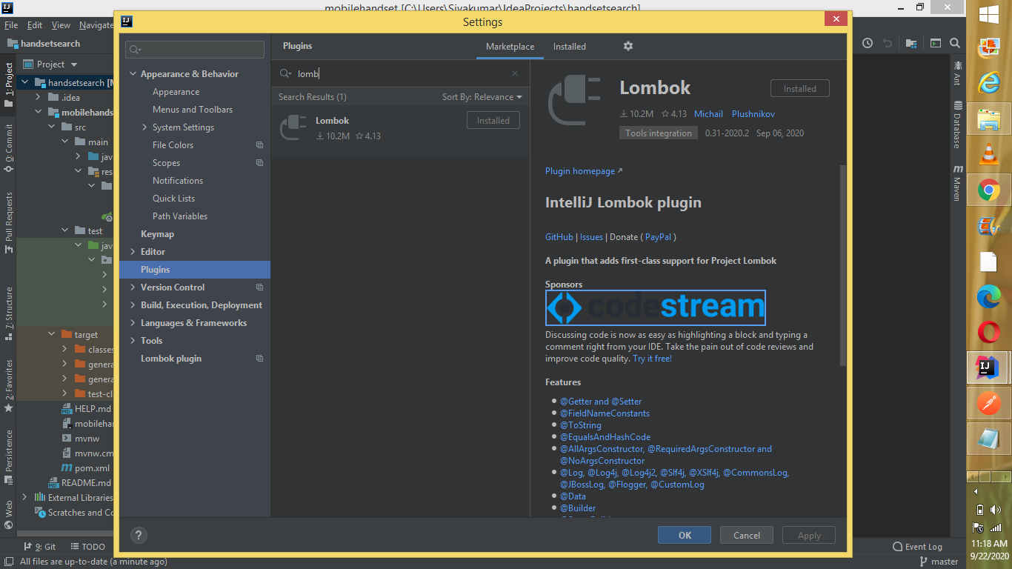

mobile/search?sim=eSIM - This is case sensitive, we should pass the value as ‘**eSIM’**

mobile/search?priceEur=200

<http://localhost:8080/mobile/search?priceEur=200&announcedDate=1999>

